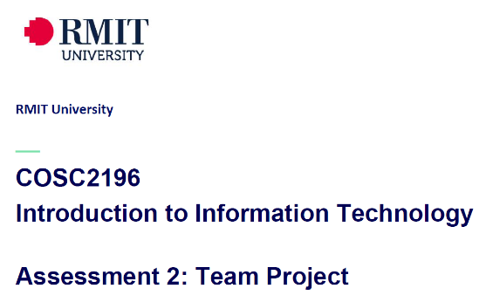**A2, Group #4 MEETING**

**Venue:** Online via MS Teams

**Date: 13-4-21**

**Minutes**

**Meeting Opened: 8.10pm**

**Attendance: Paul Eccarius, Rebecca Watson, Martin Lee, Nour Zeroual, Jarrad Hofman-Agar**

**Apologies:**

**Meeting Chair: Paul**

**Minutes Secretary: Rebecca**

1. **Minutes from previous Meeting -**

* **Actions arising as per Action Register**

|  |  |  |  |  |  |
| --- | --- | --- | --- | --- | --- |
| **Meeting Date** | **Action** | **Who to action** | **Completed Y/N** | **Update at meeting** | **Further action** |
| 31/3/21 | Profile & IT Jobs Collation | Rebecca | Draft Complete | 13/4/21 | Put profile photos in report (to match website) grab from Github |
| 31/3/21 | Github & Archiving | Paul | In hand, ongoing near completion | 13/4/21 | Framework is there, Paul to finalise content as it is completed-  All team members now need to start pushing on to Github for collaboration of Team project.  Nour & Jarrad to push their photos in to the images folder and in the html |
| 31/3/21 | Interview Questions & Appointment | Nour | Update | 13/4/21 | Nour to hold the interview tomorrow |
| 31/3/21 | Industry Information – Revist on 6/4/21 | Jarrad |  | 13/4/21 | Reference correctly and write out a bibliography |
| 31/3/21 | IT Technologies Report:    Martin: Cybersecurity  Rebecca: Cloud Services  Nour: Machine Learning  Paul: Raspberry Pi etc. | Team | Martin: Done  Rebecca: Done  Nour: editing words  Paul: also editing | 13/4/21 |  |
| 31/3/21 | Project Ideas | Team | Ongoing - See discussion in minutes. | 13/4/21 |  |

1. **Project Ideas**

* 1500 words
* Funding needs to be addressed. Subscription model – eg premium. Reference. Part of the membership could be no adds and special offers. Eg. Spotify.
* Motivation – how many people own dog, how many people live in apartments. Background on why the app is useful, how much people spend on their pets. Sustainability addressed here. (**Paul)**
* Description – the overview was expanded for this. Possibly **funding** goes in this section. (**Martin**)
* Tools & tech – cloud and coding. Swift, android studio by google, ios. Data security.
* Skills – what skills do we need? Data retention/plan, software coding skills, cloud architecture and storage, CRM software, security/privacy, marketing. A list of what Iphone and Android need, AWS for infrastructure. Scalability will be addressed with really robust cloud and then expansion can be infinite. (**Paul**)
* Data – will tie in with some of the tools and tech + skills (**Bec**)
* Outcome items – business plan, scale on rolling out the app – start small and go by stages. (**Nour**)
* Basically expanding on the overview that Martin has already done.

1. **Additional points for discussion?**

* Bibliography and collation for overall/finished document. Can Paul share his layout/template for the design of his A1 document?
* Anthony has mentioned on his chat tonight that the deadline for A2 might change and will announce either tonight or tomorrow.
* Flagged the need for Group Reflection at the end – 200 words each and then 400 words as a group.
* Deadlines – aim to have everything except the reflection done for Friday night – on the website and in the report. Paul will take care of the bibliography.
* Start committing to Github.

**Next meeting date: Sunday 18/4/21 at 8pm**

**Meeting closed: 9.15pm**

**Actions Register**

|  |  |  |  |  |  |
| --- | --- | --- | --- | --- | --- |
| Meeting Date | Action | Who to action | Completed Y/N | Update at meeting | Further action |
|  |  |  |  |  |  |